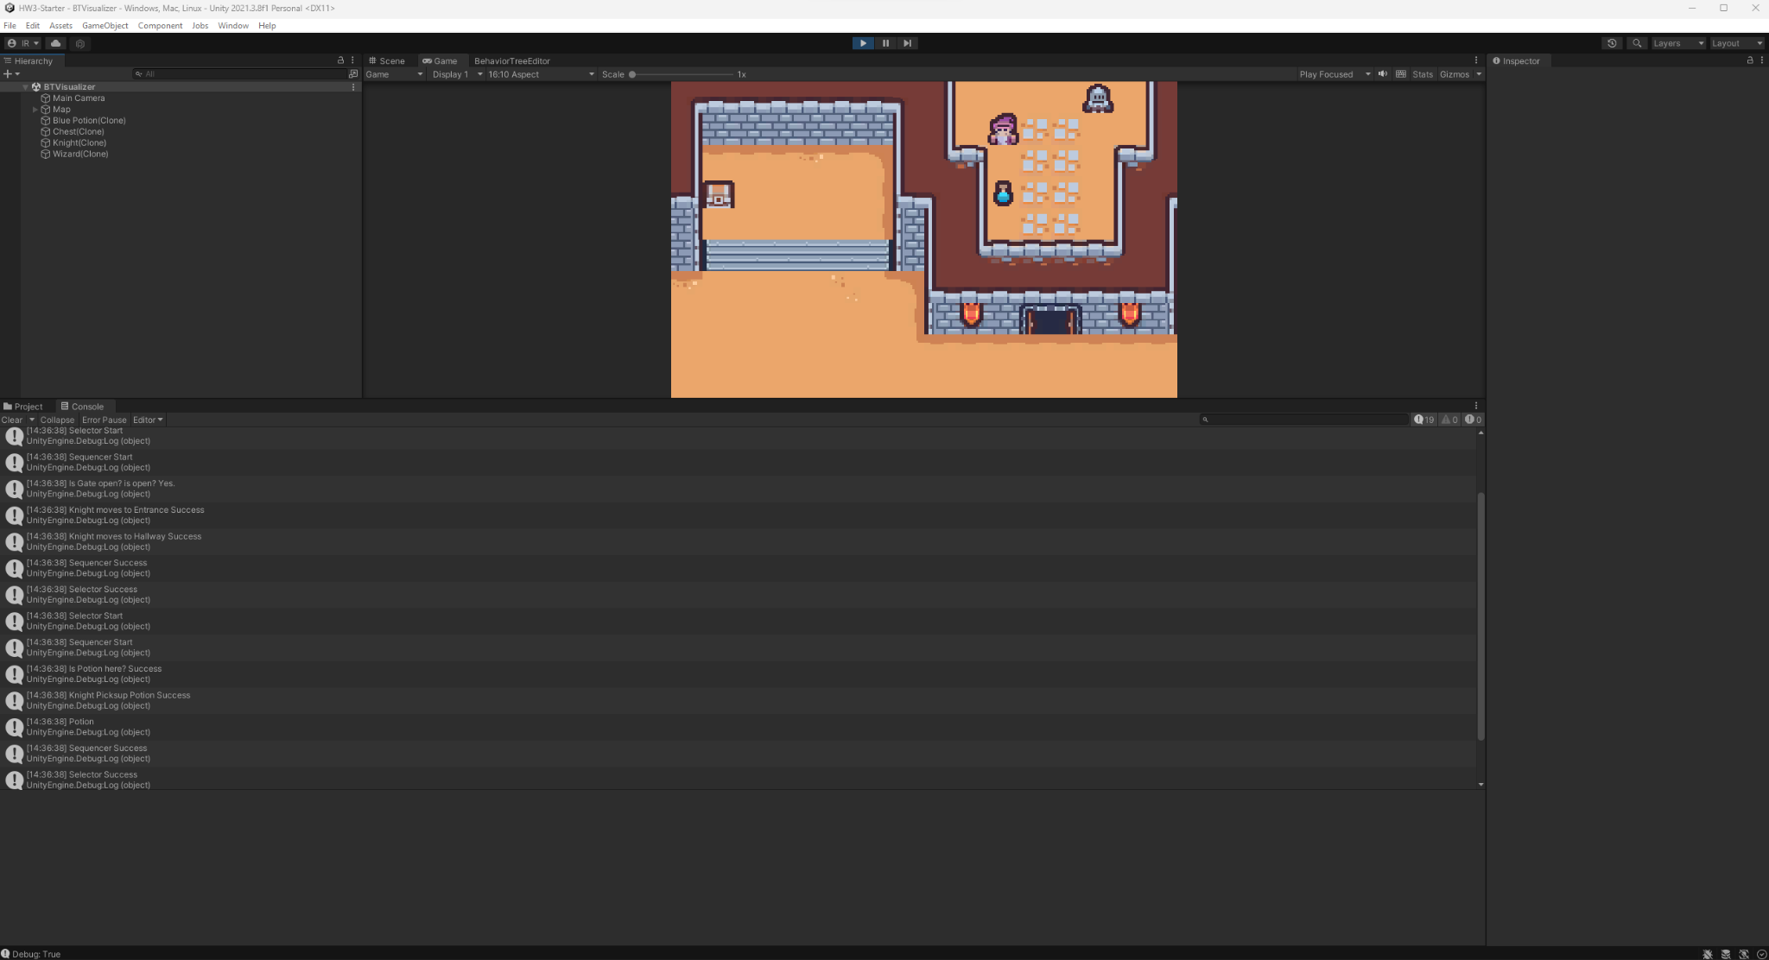

I implemented the pickup action and isHere condition into the behavior tree. To develop the behavior tree I used a whiteboard to map everything out beforehand.